Hive Partitions & Bucketing

What are the Hive Partitions?
Apache Hive organizes tables into partitions. Partitioning is a way of dividing a table into related parts based on the values of particular columns like date, city, and department. Each table in the hive can have one or more partition keys to identify a particular partition. Using partition it is easy to do queries on slices of the data.

Why is Partitioning Important?
In the current century, we know that the huge amount of data which is in the range of petabytes is getting stored in HDFS. So due to this, it becomes very difficult for Hadoop users to query this huge amount of data.
The Hive was introduced to lower down this burden of data querying. Apache Hive converts the SQL queries into MapReduce jobs and then submits it to the Hadoop cluster. When we submit a SQL query, Hive read the entire data-set. So, it becomes inefficient to run MapReduce jobs over a large table. Thus this is resolved by creating partitions in tables. Apache Hive makes this job of implementing partitions very easy by creating partitions by its automatic partition scheme at the time of table creation.
In Partitioning method, all the table data is divided into multiple partitions. Each partition corresponds to a specific value(s) of partition column(s). It is kept as a sub-record inside the table’s record present in the HDFS. Therefore on querying a particular table, appropriate partition of the table is queried which contains the query value. Thus this decreases the I/O time required by the query. Hence increases the performance speed.

Types of Hive Partitioning
Till now we have discussed Introduction to Hive Partitions and How to create Hive partitions. Now we are going to introduce the types of data partitioning in Hive. There are two types of Partitioning in Apache Hive-
- Static Partitioning
- Dynamic Partitioning
Let’s discuss these types of Hive Partitioning one by one-

i. Hive Static Partitioning
- Insert input data files individually into a partition table is Static Partition.
- Usually when loading files (big files) into Hive tables static partitions are preferred.
- Static Partition saves your time in loading data compared to dynamic partition.
- You “statically” add a partition in the table and move the file into the partition of the table.
- We can alter the partition in the static partition.
- You can get the partition column value from the filename, day of date etc without reading the whole big file.
- If you want to use the Static partition in the hive you should set property set hive.mapred.mode = strict This property set by default in hive-site.xml
- Static partition is in Strict Mode.
- You should use where clause to use limit in the static partition.
- You can perform Static partition on Hive Manage table or external table.

ii. Hive Dynamic Partitioning
- Single insert to partition table is known as a dynamic partition.
- Usually, dynamic partition loads the data from the non-partitioned table.
- Dynamic Partition takes more time in loading data compared to static partition.
- When you have large data stored in a table then the Dynamic partition is suitable.
- If you want to partition a number of columns but you don’t know how many columns then also dynamic partition is suitable.
- Dynamic partition there is no required where clause to use limit.
- we can’t perform alter on the Dynamic partition.
- You can perform dynamic partition on hive external table and managed table.
- If you want to use the Dynamic partition in the hive then the mode is in non-strict mode.
- Here are Hive dynamic partition properties you should allow

Hive Partitioning – Advantages and Disadvantages
Let’s discuss some benefits and limitations of Apache Hive Partitioning-
a) Hive Partitioning Advantages
- Partitioning in Hive distributes execution load horizontally.
- In partition faster execution of queries with the low volume of data takes place. For example, search population from Vatican City returns very fast instead of searching entire world population.
Hive Partitioning Disadvantage
- There is the possibility of too many small partition creations- too many directories.
- Partition is effective for low volume data. But there some queries like group by on high volume of data take a long time to execute. For example, grouping population of China will take a long time as compared to a grouping of the population in Vatican City.
- There is no need for searching entire table column for a single record.

Sample Example:
After run the following sql, to create table and insert data. We can see the following data in hive, mysql and hdfs
CREATE TABLE Customer_transactions (
Customer_id VARCHAR(40),
txn_amout DECIMAL(38, 2),
txn_type VARCHAR(100))
PARTITIONED BY (txn_date STRING)
ROW FORMAT DELIMITED FIELDS TERMINATED BY '|' LINES TERMINATED BY '\n'
STORED AS TEXTFILE;

insert into Customer_transactions
partition(txn_date)
values
('101',2000, 'Dredit','2019-10-02');
insert into Customer_transactions
partition(txn_date)
values
('100',1000, 'Credit','2020-10-02');

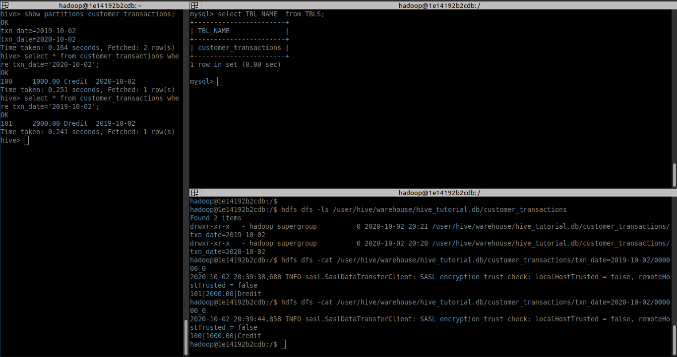

Why Bucketing?
Basically, the concept of Hive Partitioning provides a way of segregating hive table data into multiple files/directories. However, it only gives effective results in few scenarios. Such as:
– When there is the limited number of partitions.
– Or, while partitions are of comparatively equal size.
Although, it is not possible in all scenarios. For example when are partitioning our tables based geographic locations like country. Hence, some bigger countries will have large partitions (ex: 4-5 countries itself contributing 70-80% of total data). While small countries data will create small partitions (remaining all countries in the world may contribute to just 20-30 % of total data). Hence, at that time Partitioning will not be ideal.
Then, to solve that problem of over partitioning, Hive offers Bucketing concept. It is another effective technique for decomposing table data sets into more manageable parts.
The bucketing in Hive is a data organizing technique. It is similar to partitioning in Hive with an added functionality that it divides large datasets into more manageable parts known as buckets. So, we can use bucketing in Hive when the implementation of partitioning becomes difficult. However, we can also divide partitions further in buckets.
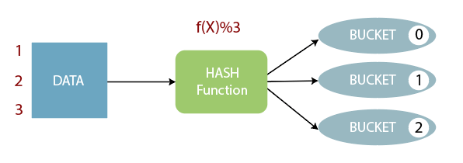

Features of Bucketing in Hive
Basically, this concept is based on hashing function on the bucketed column. Along with mod (by the total number of buckets).
i. Where the hash_function depends on the type of the bucketing column.
ii. However, the Records with the same bucketed column will always be stored in the same bucket.
iii. Moreover, to divide the table into buckets we use CLUSTERED BY clause.
iv. Generally, in the table directory, each bucket is just a file, and Bucket numbering is 1-based.
v. Along with Partitioning on Hive tables bucketing can be done and even without partitioning.
vi. Moreover, Bucketed tables will create almost equally distributed data file parts.

Advantages of Bucketing in Hive
i. On comparing with non-bucketed tables, Bucketed tables offer the efficient sampling.
ii. Map-side joins will be faster on bucketed tables than non-bucketed tables, as the data files are equal sized parts.
iii. Here also bucketed tables offer faster query responses than non-bucketed tables as compared to Similar to partitioning.
iv. This concept offers the flexibility to keep the records in each bucket to be sorted by one or more columns.
v. Since the join of each bucket becomes an efficient merge-sort, this makes map-side joins even more efficient.

Limitations of Bucketing in Hive
i. However, it doesn’t ensure that the table is properly populated.
ii. So, we need to handle Data Loading into buckets by our-self.

Sample Example:
To populate the bucketed table, we have to set hive.enforce.bucketing property to ‘true’, so that the Hive knows to create the number of buckets declared in the table definition.
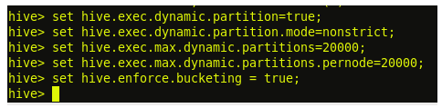
The property hive.enforce.bucketing = true is similar to hive.exec.dynamic.partition = true, in Hive partitioning. By setting this property, we will enable dynamic bucketing while loading data into the Hive table.
The above hive.enforce.bucketing = true property sets the number of reduce tasks to be equal to the number of buckets mentioned in the table definition (Which is ‘4’ in our case) and automatically selects the clustered by column from table definition.

After run the following sql, to create table and insert data. We can see the following data in hive, mysql and hdfs

CREATE TABLE students (name VARCHAR(64), age INT, gpa DECIMAL(3,2)) CLUSTERED BY (age) INTO 2 BUCKETS STORED AS TEXTFILE;

INSERT INTO TABLE students VALUES ('aaaa', 34, 1.28);
INSERT INTO TABLE students VALUES ('bbbb', 34, 1.3);
INSERT INTO TABLE students VALUES ('cccc', 330, 1.3);
INSERT INTO TABLE students VALUES ('dddd', 35, 1.4);

